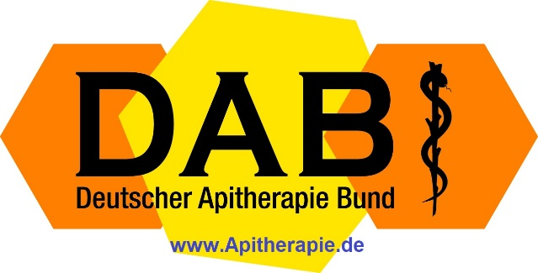

Workshop for Advanced Apitherapists 2026

Bad Königshofen – Workshop Room
Monday, 30 March 2026
An intensive practical day for physicians, naturopaths, therapists, pharmacists, and experienced beekeepers with a therapeutic interest.

Why this workshop is especially worthwhile
- Concrete apitherapy protocols that can be implemented immediately in daily practice
- Practical demonstrations and clinically oriented discussions
- Valuable additional topics from the international hands-on workshops of Dr. med. Stefan Stângaciu
- Direct exchange of experience with colleagues and lecturers

Programme
Time | Content
09:00–09:20 | Registration
09:20–09:30 | Welcome
09:30–10:00 | Introduction round
10:00–10:45 | Dr. med. Stefan Stângaciu: Cardiovascular and Metabolic Diseases in Apitherapy – Overview
10:45–11:00 | Coffee break
11:00–12:00 | Dr. med. Stefan Stângaciu: Treatment Protocols for Various Metabolic Diseases
12:00–12:45 | Dr. med. Stefan Stângaciu, Antonio Couto, Moises Javier Morales: Bee Sting Therapy for Metabolic Diseases
13:00–14:30 | Lunch break with excursion to the beehive-air station of the Bad Königshofen Beekeepers’ Association at the Rhön-Grabfeld Bee Center
14:30–15:15 | Naturopath Marion Vomberg: Honey Massage (with handout)
15:15–16:00 | Dr. med. Stefan Stângaciu & Dr. med. Matthias Holeiter: The Use of Apitherapy Cocktails as Adjunctive Therapy in Diseases, Including Metabolic Disorders
16:00–16:15 | Coffee break
16:15–17:00 | Round table, questions, and integration of the practical additional topics
17:00–17:15 | Closing and outlook

Additional practical topics that may be explained or—where possible—demonstrated during the workshop
- Prevention and integrative treatment of allergies using bee products, medicinal plants, and essential oils
- Practical techniques for administering honey and propolis via the lungs
- Best techniques of beehive-air therapy: indications, practical application, hygiene, and typical sources of error
- Practical preparation and application of propolis, honey, and pollen preparations, including extracts, tinctures, creams, suppositories, ovules, and eye preparations
- Cold extraction of active principles from propolis and bee pollen in olive oil
- Microfiltered and diluted honey for eye applications, including sterile work with 0.22-micrometer filters
- How to prepare bee venom injections and perform bee stings without killing the bees
- How to identify high-quality, unadulterated bee products and avoid typical quality defects
- How to create patient-specific apitherapy protocols and apitherapy cocktails
- Practical guidance on building a medically oriented apiary, an apitherapy shop, or an apitherapy center
- The selection of topics can be adapted to the needs of the group, ensuring the workshop remains practical, lively, and immediately applicable.

Especially attractive for participants
- Compact training with high practical value
- Many contents from international hands-on workshops in over 60 countries
- Suitable for experienced therapists who wish to expand their apitherapeutic repertoire
Registration and information: vorstand@apitherapie.de | www.apitherapie.de

