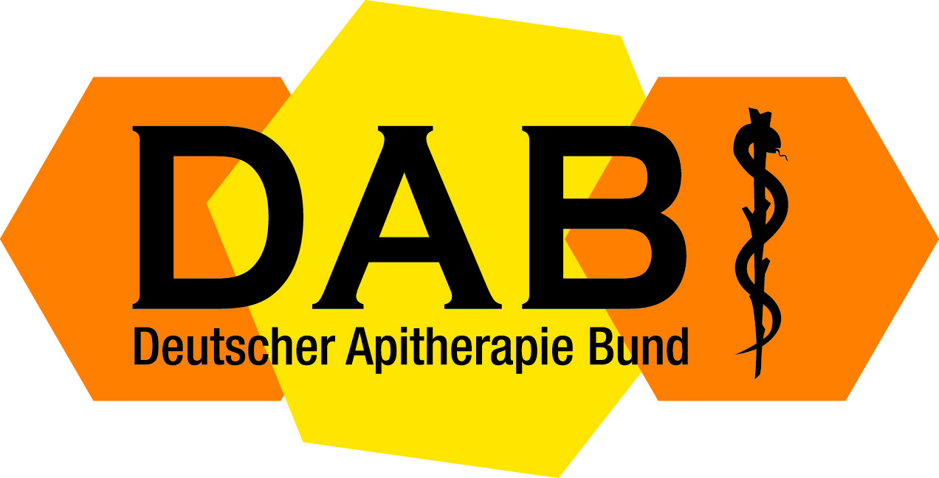 Registration exhibitors
zum 18. Apitherapy Congress, March 2023
31.3. – 02.04.2023

Company: …………………………………………………………..

Street: .………………………………………………………….

Postalcode and City .………………………………………………………….

E-Mail: …………………………………………………………..

Phone-number: ….………………………………………………............

Member DAB: yes □ / no □
1. participant : ( Free participation in the congress when booking an information table )
Name und Prename: …..………………………………………………………

I speak the following languages: deutsch □ engl. □ franz. □ span. □ others □
Multiple answers possible....

Nationality: ….…………………………………………………..….

2. participant: ( Free participation in the congress when booking an information table )
Name und Prename: ……….………..………………………………………..

I speak the following languages: deutsch □ engl. □ franz. □ span. □ andere □
Multiple answers possible ...............

Nationality: ….…………………………………………………..….

Please check:
Price
Infotable ca. 0,7x0,7m □ 120,-- € ( only for DAB Members )
Expo-Table (2x2m) □ 500,-- € ( 350,-- € for DAB Members )
Expo-Table (3x2m) □ 750,-- € ( 525,-- € für DAB Members )
Expo-Table (4x2m) □ 1.000,-- € ( 700,-- € für DAB Members )

Please use the registration form for the congress to register additional participants and for city tours.

The transfer amount is …….………€
( for international transfers, please pay all fees to the client! )

Date, Signature …………………………………..
please fill it out legibly and send it to DAB by fax, e-mail or post.

Questions to:
Deutscher Apitherapiebund e.V.
Weidenbachring 14 , 82362 Weilheim-Marnbach Germany.
Tel: +0049-881/ 92451395
Fax: +0049-881/9095730
E-mail: verwaltung@apitherapie.de + arno.bruder@t-online.de

