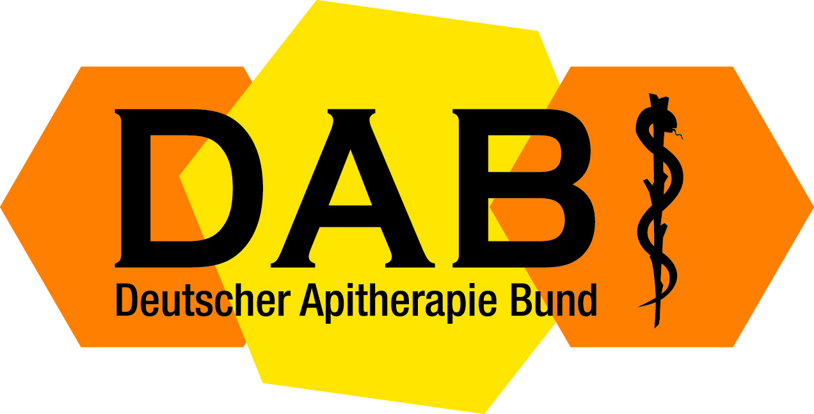

entrance fees

Congress – und Workshop

Congress 31th. March / 02th. April 2023
early bird (not DAB member)
1 day 2 days 3 days
50 € 90 € 120 €

late registration (not DAB member)
1 day 2 days 3 days
80 € 120€ 150 €

early bird (DAB member)
1 day 2 days 3 days
30 € 60 € 90 €

late registration (DAB member)
1 day 2 days 3 days
40 € 80 € 100 €

Sunday 02th April 2023 (after congress) city tour and visit to the world-famous Semper Opera

The fee is 30 €

Workshop 03. April 2023

 | Early bird | Late registration | Early bird Member | Late registration Member
1 Day | 150 € | 180 € | 90 € | 100 €

The deadline for the early bird discount is receipt of the transfer by February 28, 2023 at the latest
Bank details:
Bankverbindung: Sparda-Bank München
IBAN: DE207 009 050 000 032 977 80.
BIC (Swift-Code): GENODEF 1 S 04

Zweigstelle Lehel, Triftstraße 4, 80538 München, Germany.
Tel. 089/212135-0.

