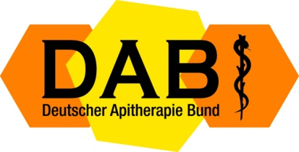
German Apitherapy Society e. V.
Weidenbachring 14, 82362 Weilheim-Marnbach, Germany
Tel.: 0049-881-92451395 Fax: 0049-881-9095730
@: verwaltung@apitherapie.de www.apitherapie.de
Weilheim, den 20.01.2023

To:

Official Invitation

Dear Apitherapy Friends,

We are honored to invite you to our 18-th International German Apitherapy Congress and Api-Expo with International Participation to be held in Dresden, Germany, Mauersberger Saal ( Central Dresden ) from March 31 to April 03, 2023

Should you have any more questions, please feel free and contact us by Mail, Phone and/or
Fax at our above address.

Phone: 0049-8819095731 or Mobil 0049-15159455647
Fax: 0049-8819095730
Mail: verwaltung@apitherapie.de or arno.bruder@apitherapie.de

All information you find on our website:

www.apitherapie.de

Sincerely yours,

ARNO BRUDER
President of the German Apitherapy Society

